# **Need a room for Wednesday night?**

# **Please see these alternate hotel options:**

# The Inn at Opryland, A Gaylord Hotel

2401 Music Valley Drive Nashville, TN 37214

$173

Book [here.](https://www.marriott.com/en-us/hotels/bnagi-the-inn-at-opryland-a-gaylord-hotel/overview/)

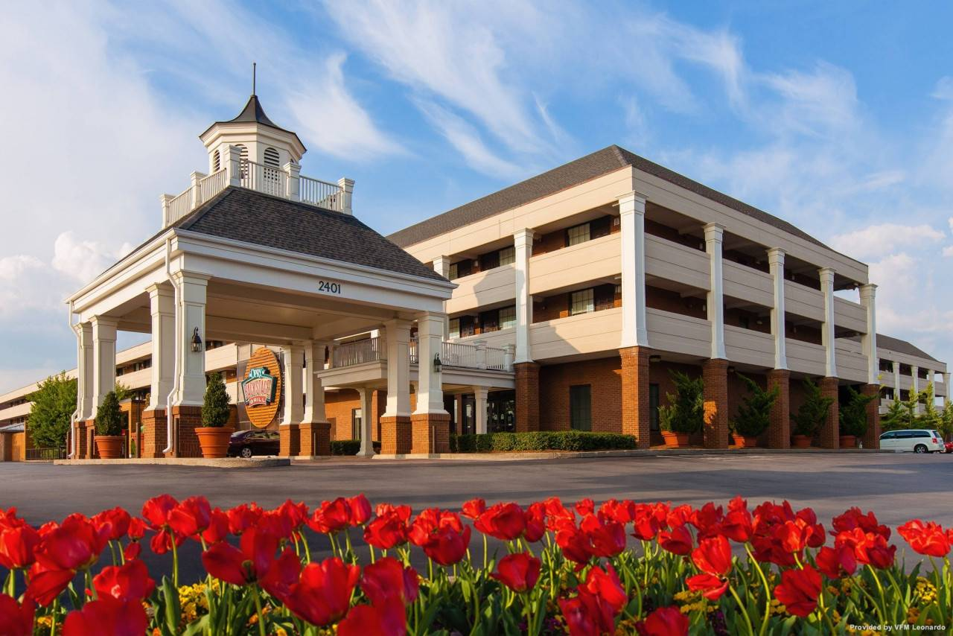

# Residence Inn by Marriot Nashville at Opryland

2500 Music Valley Drive Nashville, TN 37214

$188

Book [here.](https://www.marriott.com/en-us/hotels/bnaol-residence-inn-nashville-at-opryland/overview/)

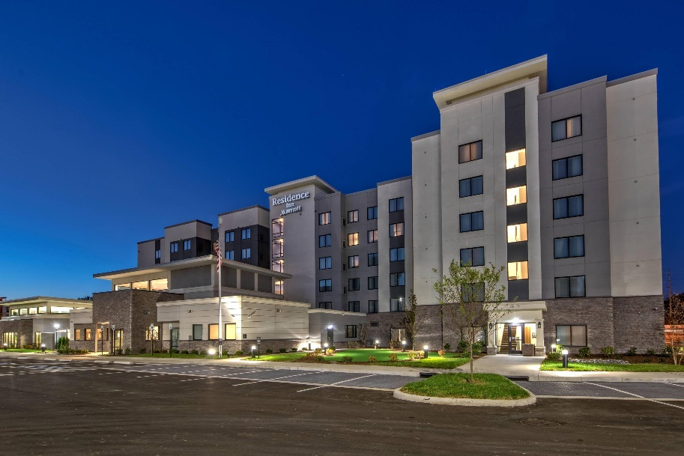

# Country Inn & Suites by Radisson

210 Rudy Circle Nashville, TN 37214

$139

Book [here.](https://www.choicehotels.com/tennessee/nashville/country-inn-suites-hotels/tna22?mc=llbillpx&pmf=local)

